

## VISVESVARAYA TECHNOLOGICAL UNIVERSITY

JNANA SANGAMA, BELAGAVI - 590 014

**An Internship Report on Weather Prediction Model**

**Submitted by**

**Anish Kumar**

**1AY21CS028**

**Under the Guidance of**

**Dr Ajith Padyana**

**Professor and Head**

**Dept. of CSE, AIT**

**2023-2024**

**DEPARTMENT OF COMPUTER SCIENCE AND ENGINEERING**

**Acharya Institute of Technology**

**Acharya Dr. Sarvepalli Radhadrishnan Road, Soladevanahalli, Bengaluru-560107**

# ACHARYA INSTITUTE OF TECHNOLOGY

#### Hesaraghatta Road, Dr. Sarvepalli Radhakrishnan Road Bengaluru 560107

**DEPARTMENT OF ELECTRONICS AND COMMUNICATION ENGINEERING.**



**CERTIFICATE**

Certified that the Internship entitled “No abbreviations” is carried out **by Anish Kumar bearing USN 1AY21CS028** in the partial fulfillment for the award of degree of Bachelor of Engineering in **Computer Science and Engineering** of **Visvesvaraya Technological University**, Belagavi during the year 2023-2024. It is certified that all corrections/suggestions indicated for the assessment have been incorporated in the report deposited in the departmental library. The Internship Report has been approved as it satisfies the academic requirement in respect of **Innovation/Entrepreneurship /Societal Internship (21INT68)** prescribed for the Bachelor of Engineering Degree.

|  |  |  |
| --- | --- | --- |
| ……………………. | …………………… | …………………… |
| Signature of Guide | Signature of HOD | Signature of Principal |
| Dr. Ajith Padyana | Dr. Ajith Padyana | Dr. Rajeshwari |
| Professor and Head | Professor and Head | Principal, AIT |
| Dept. of CSE, AIT | Dept. of CSE, AIT |  |

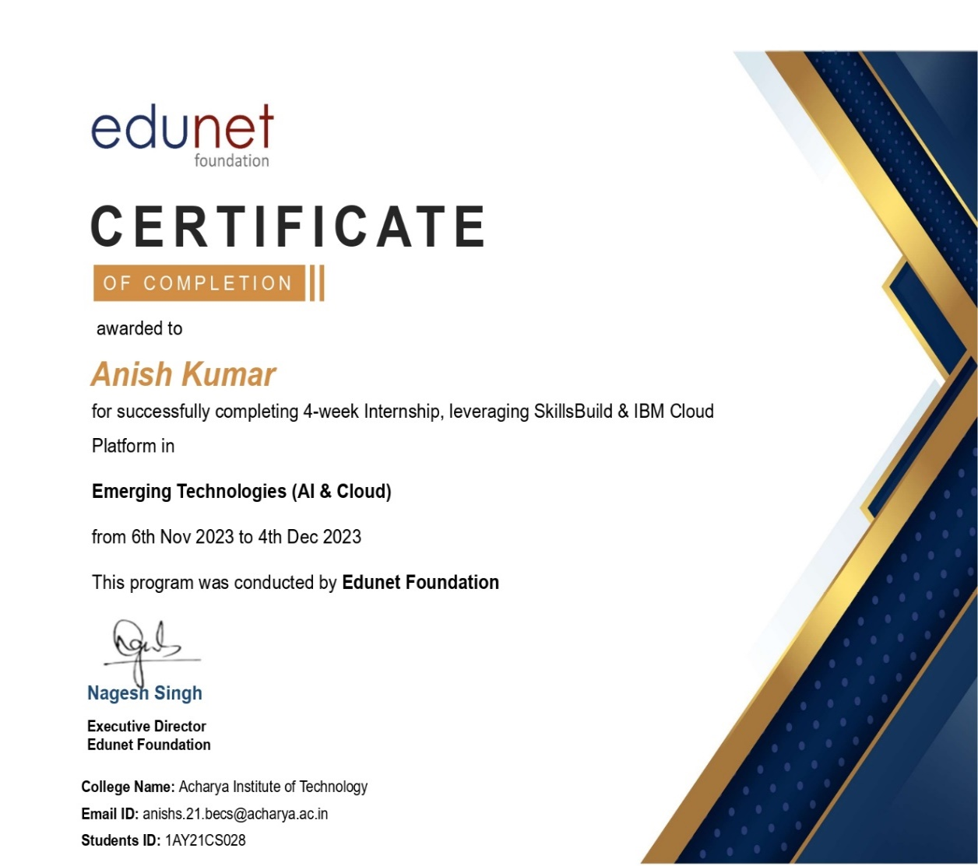

# ACHARYA INSTITUTE OF TECHNOLOGY

#### Hesaraghatta Road, Dr. Sarvepalli Radhakrishnan Road Bengaluru 560107

**DEPARTMENT OF COMPUTER SCIENCE AND ENGINEERING.**



2023-2024

**DECLARATION**

I, Anish Kumar, 1AY21CS028, hereby declare that the Internship work entitled **Weather Prediction Model** has been independently carried out by me under the supervision of Dr. Ajith Padyana, Professor and Head, Department of Computer Science and Engineering, Acharya Institute of Technology in partial fulfilment of the requirement for the award of the degree of **Bachelor of Engineering** in **Computer Science and Engineering** by **Visvesvaraya Technological University, Belagavi** during the year **2023-24.**

**Place: Anish Kumar**

**Date: 1AY21CS028**

**ACKNOWLEDGEMENT**

The satisfaction and euphoria that accompany the successful completion of a task would be incomplete without the mention of the people who made it possible and without their constant guidance and encouragement; success would not have been possible.

I am grateful to the institute **Acharya Institute of Technology** and management with its ideas and inspiration for having provided us with the good infrastructure, laboratory, facilities and inspiring staff which has made this seminar report complete successfully.

I would like to express my sincere gratitude to **Dr. Rajeshwari, Principal, AIT and Prof. C K Marigowda, Vice-Principal, AIT** for all the facilities that has been extended throughout my work.

I heartily thank and express my sincere gratitude to **Dr. Ajith Padyana, Professor and Head, Dept. of CSE, AIT** for her valuable support and a constant source of enthusiastic inspiration to steer us forward.

I would like to express my sincere gratitude to the Internal Guide **Dr. Ajith Padyana, Professor and Head, Dept. of CSE, AIT** for her invaluable guidance and support.

I would like to express my sincere gratitude to the Internship Coordinators **Jawahar Jonathan K Assistant Professor, Dept. of CSE, AIT** for their valuable guidance and support.

Finally, I would like to express my sincere gratitude to my parents, all teaching and non- teaching faculty members and friends for their moral support, encouragement and help throughout the completion of the Technical Seminar.

**NAME Anish Kumar**

**USN 1AY21CS028**

## ABSTRACT

In this study, we develop a weather prediction model utilizing Python and its powerful machine learning libraries, including Keras, Scikit-learn, NumPy, and Pandas. The model is trained and evaluated using historical weather data from Los Angeles, aiming to predict future weather conditions with high accuracy. The dataset, which includes variables such as temperature, humidity, wind speed, and atmospheric pressure, was preprocessed using Pandas for data cleaning and manipulation. NumPy was employed for efficient numerical computations. Feature engineering and selection were performed to enhance the model's predictive performance.

We constructed a deep learning model using Keras, a high-level neural networks API, with TensorFlow as the backend. The architecture comprises multiple dense layers designed to capture complex patterns in the weather data. To prevent overfitting, techniques such as dropout regularization and early stopping were implemented. Additionally, Scikit-learn was used for data splitting, standardization, and evaluation of the model's performance through metrics such as Mean Absolute Error (MAE) and Root Mean Squared Error (RMSE). The model was trained on a substantial portion of the dataset and validated on unseen data to ensure its generalizability.

## TABLE OF CONTENTS

**Acknowledgement i**

Abstract ii

Table of Contents iii

List of Figures iv

**Chapters Page No.**

1. **About the Company 1**
   1. **About IBM 1**
   2. **Key Areas of Operation 1**
2. **Introduction to the domain of internship 2-3**
   1. **Data Science 2**
   2. **Machine Learning 2-3**
3. **Technologies and Tools 4-5**
   1. **Python Libraries 4**
   2. **Scikit-learn (sklearn) 4**
   3. **Keras with TensorFlow Backend 4-5**
   4. **Weather Data Analysis and Visualization 5**
4. **Effective Preprocessing Enhances Model Performance 6**
5. **Neural Network Architecture and Training Efficacy 7**
6. **Visualization as a Diagnostic Tool 8**
7. **Getting Started with Enterprise Data Science – course 9**
8. **Summary 10**

**References**

**Appendix**

## LIST OF FIGURES

**Figure No Page No.**

* 1. **IBM LOGO 1**
  2. **MinMaxScaler Output 5**
  3. **Neural Network Output 6**

**6.1 Visualization Output 7**

**7.1 Data Science Certificate 8**